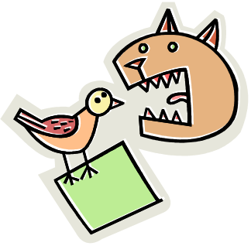
SlyCat has long suspected a crime ring among the dogs in the neighborhood but has not yet been able to come up with concrete evidence. Finally, there’s a breakthrough in his investigation when he intercepts a wireless communication among some hacker mutts down near the dog pound. SlyCat suspects a breakout attempt with help from the hackers, but needs to identify the sources. Here’s his problem.

You will be given command line arguments in the following form:
- A string with the jumble.
- Followed by several strings, space delineated, of the names of the dog suspects SlyCat is trying to identify in the jumble.

Your job is to help SlyCat identify which, if any, of the dogs’ names is part of the jumbled letters. Since you have never done any work for SlyCat before, he does not trust you to use any clever trick. Therefore, you are required to check every possible permutation of the letters given. You are also required to use the Java Vector class as discussed in class.

Output is left, in part, to your discretion. It must be well presented and clear. You must indicate which names are can be derived from the jumble and you must also indicate the total number of permutations. Output style and originality are part of your grade.

Details:
- A name may be shorter than the jumble. For example, ‘mo’ is in ‘gumshoe’.
- All letters must be present. For example, ‘bob’ is not part of ‘laboratory’.

Example input: (‘gumshoe’ is the jumble provided followed by dog suspects)
gumshoe milo mugs otis mo max

Your program should be able to identify ‘mugs’ and ‘mo’ as part of the gang.
Submission Details

- Due Date is Wednesday, September 21, 2005, 6:40 p.m. (5% late penalty until midnight.)
- Email your source file to Pawan Seth ps36@uakron.edu and cc to liszka@uakron.edu.
- The subject line should be “dsa2-dogpound” and your name must be in the body of the email.
- This is not a group project. Cooperative work will not be tolerated.
- Hand in a hardcopy of your code with the SIGNED academic integrity cover sheet. Your program will not be graded without this. In addition, please print your name beside your signature. (Some of you write worse than me!)
- Follow the “Documentation and Style Guidelines” posted on the course webpage. These originated from Cay Horstmann’s “Big Java” text, were modified by Dr. Margush, and modified again for this class.

